Chapter 5, Solution 76.

The schematic is shown below. IPROBE is inserted to measure i_{o}. Upon simulation, the value of i_{o} is displayed on IPROBE as

i_{o} = –562.5 μA

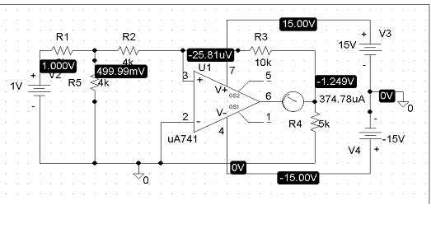
750 mV
0.750V
375mV
11.25V
–19.358uV
–11.25V
–936.8mV
2 kΩ

